**TITLE OF PAPER**

**[Title: uppercase, Times New Roman, font size 14, centered, single spacing paragraph]**

Author Name1*, Author Name2, Author Name1

**[Authors’ full name should be provided, Times New Roman, font size 10, superscript 1, 2, 3 etc. to indicate affiliation, centered, single spacing paragraph, do not provide superscript numbers if all authors belongs to same school/department/institution]**

*1School of Chemistry and Environment, Faculty of Applied Sciences*

*2School of Biological Sciences, Faculty of Applied Sciences*

*Universiti Teknologi MARA (UiTM), Cawangan Negeri Sembilan, Kampus Kuala Pilah, 72000 Kuala Pilah, Negeri Sembilan, Malaysia*

**[Indicate authors’ affiliation with superscript 1, 2, 3 etc. and start each address on new line, Times New Roman, font size 9, italic, centered, single spacing paragraph, if the authors are from different institution then full postal address including postal code, city and country should be provided]**

*\*Corresponding author: email address***[Times New Roman, font size 9, italic, only ONE corresponding author is allowed]**

**Abstract**

This template provides formatting guidelines for authors in the preparation of manuscript for publication in the Journal of Academia. The authors must strictly follow the instructions given in this template for their manuscript preparation.

**[Maximum number of words for abstract is 300. Use Times New Roman, 11 point font with text justified and single spacing paragraph]**

**Keywords**: **[maximum 5, Times New Roman, font size 9 and text position left. Leave ONE blank line after abstract]**

*Article History:- Received: DD MM YY; Revised: DD MM YY; Accepted: DD MM YY; Published: DD MM YY*

*© by Universiti Teknologi MARA, Cawangan Negeri Sembilan, YYYY, e-ISSN: 2289-6368*

**Introduction**

**[All first order headings use Times New Roman, font size 11, bold and centered]**

This template provides formatting guidelines for authors in the preparation of manuscript for publication in the Journal of Academia. The authors must strictly follow the instructions given in this template for their manuscript preparation.

The Introduction section should contain background about the research, problem statement, significance of the research and do mention the originality/novelty of your research. It is not advisable to use subsections such as ‘Literature review’, ‘Research Questions’ and etc.

**[The text should be justified, Times New Roman, font size 11, unindented and single spacing paragraph. All abbreviated forms should be spelled out for the first time. Use equation editor for all mathematics formulaes]**

**Methods**

**Study Area [Second order headings should be bold, Times New Roman, 11 point font, unindented, left justified]**

This template provides formatting guidelines for authors in the preparation of manuscript for publication in the Journal of Academia. The authors must strictly follow the instructions given in this template for their manuscript preparation.All abbreviated forms should be spelled out for the first time. Use equation editor for all mathematics formulaes.

**Result and Discussion**

This template provides formatting guidelines for authors in the preparation of manuscript for publication in the Journal of Academia. The authors must strictly follow the instructions given in this template for their manuscript preparation.All abbreviated forms should be spelled out for the first time. Use equation editor for all mathematics formulaes.

NOTE: The tables and figures should be followed by the text!

Table 1. **[Table text and caption should centered, Times New Roman, font size 10, included in body text]**

|  |  |  |  |
| --- | --- | --- | --- |
|  | **Title 1** | **Title 2** | **Title 3** |
| Text 1 |  |  |  |
| Text 2 |  |  |  |
| Text 3 |  |  |  |

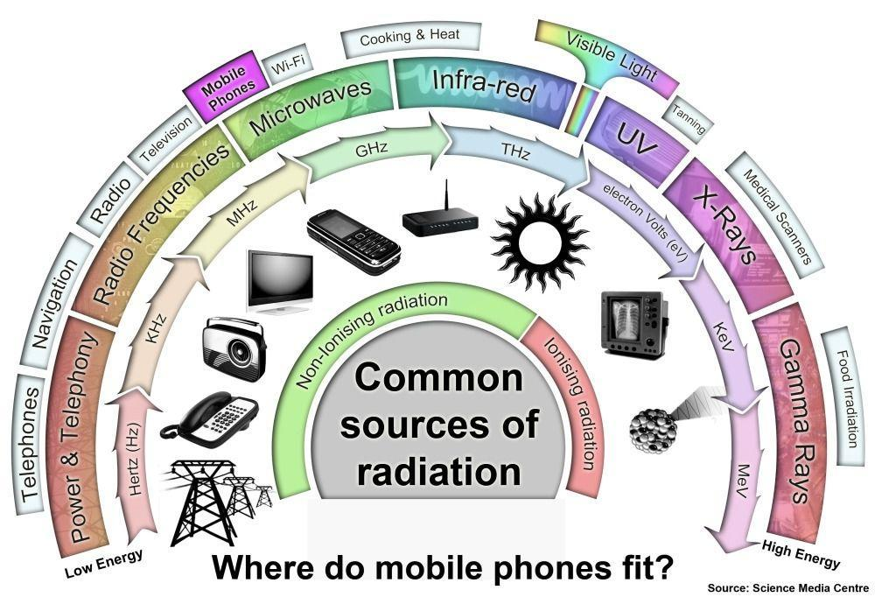

Figure 1. **[illustration text and caption should centered, Times New Roman, font size 10, included in the body text. All figures including graphical representations and spectra should be converted to TIFF format. DO NOT PROVIDE ANY FIGURES DIRECTLY FROM EXCEL]**

**Conclusion**

This template provides formatting guidelines for authors in the preparation of manuscript for publication in the Journal of Academia. The authors must strictly follow the instructions given in this template for their manuscript preparation.All abbreviated forms should be spelled out for the first time. Use equation editor for all mathematics formulas.

**Acknowledgement/Funding**

This template provides formatting guidelines for authors in the preparation of manuscript for publication in the Journal of Academia. The authors must strictly follow the instructions given in this template for their manuscript preparation.

**[Acknowledgement is a COMPULSORY section. The authors may report the funding agencies and gratitude to anyone contributed in this research if their name not included in the author’s list. If the authors did not receive any funding, kindly state: “The author(s) received no financial support for the research” Times New Roman, font size 10, justified]**

**Author Contribution**

This template provides formatting guidelines for authors in the preparation of manuscript for publication in the Journal of Academia. The authors must strictly follow the instructions given in this template for their manuscript preparation.

**[Author Contribution is a COMPULSORY section. Provide at minimum one contribution for each author in the submission system. Use the** [**CRediT taxonomy**](https://casrai.org/credit/) **(Ctrl+Click) to describe each contribution. Contributions will be published with the final article, and they should accurately reflect contributions to the work. Example: KP Sambasevam – conceptualization, data curation; SNA Baharin – Supervision, Writing – review&editing. Times New Roman, font size 10, justified]**

**Conflict of Interest**

This template provides formatting guidelines for authors in the preparation of manuscript for publication in the Journal of Academia. The authors must strictly follow the instructions given in this template for their manuscript preparation.

**[Conflict of Interest is a COMPULSORY section. Declare if there is any, otherwise write: “Authors declare no conflict of interest”. Times New Roman, font size 10, justified]**

**References**

**[References should be listed in alphabetical order, Times New Roman, font size 10, justified and single spacing paragraph with format:**

**Journal – Authors. (Years). Title of paper. Journal title (spelled full), Volume (Issue number-optional), pages. DOI (optional) (Use: APA format system)**

Eising, M., Cava, C. E., Salvatierra, R. V., Zarbin, A. J. G., & Roman, L. S. (2017). Doping effect on self-assembled films of polyaniline and carbon nanotube applied as ammonia gas sensor. *Sensors and Actuators, B: Chemical*, *245*, 25–33. <https://doi.org/10.1016/j.snb.2017.01.132>

Sambasevam, K. P., Mohamad, S., & Phang, S.-W. (2015). Effect of dopant concentration on polyaniline for hydrazine detection. *Materials Science in Semiconductor Processing*, *33*, 24–31. https://doi.org/10.1016/j.mssp.2015.01.008

**Book – Authors, years, book title. publisher name, country. volume (issue number): pages.**

Alley, E. R. (2007). *Water quality control handbook*. McGraw-Hill, New York: pp. 2 – 3.

Kleter, G. A., & Noordam, M. Y. (2015). Safety Assessment of Genetically Modified Foods. In *Advances in Food Biotechnology*. Chichester, UK: John Wiley & Sons Ltd.: pp. 27–36 https://doi.org/10.1002/9781118864463.ch03

**Thesis – author, years, thesis title, degree, and university**

Soukaina, R. (2015). Synthesis, characterization, and electrochemical properties of polyaniline thin films, Graduate Theses and Dissertations, University of South Florida

Mottaghitalab, V. (2006). Development and characterisation of polyaniline - carbon nanotube conducting composite fibres. Retrieved from http://ro.uow.edu.au/theses/491

**Webpage – author or institution, year, title, link website, date access [The web url based references shouldn’t be more than 10% of total references]**

Ministry of Health (2010). Effect of e-ciagrettes. http://www.e-cig.com.gov.my/list/. [Access online 24 August 2017].